Docker Notes

Theory
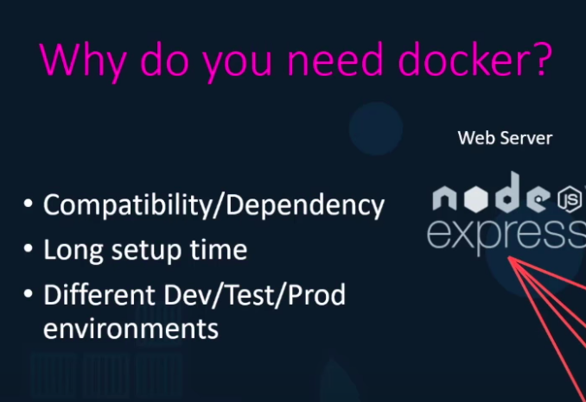

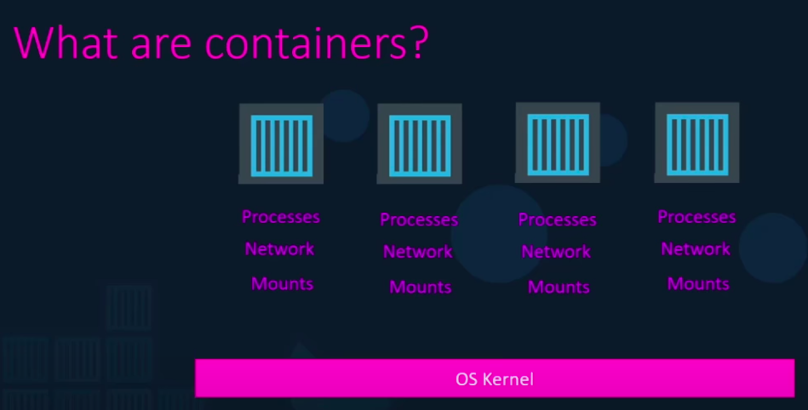

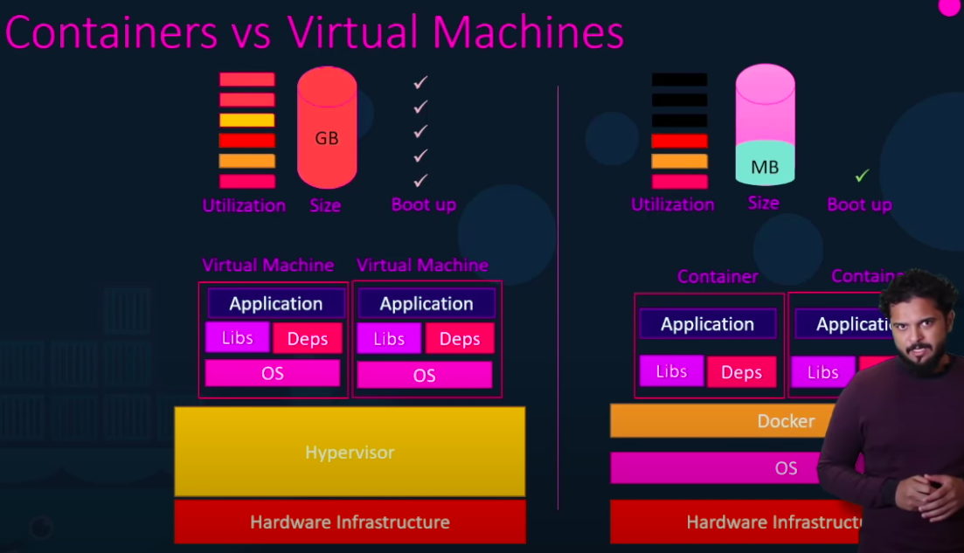
Virtual Machines are isolated and do not share their resources while Containers are very loosely packed and un-isolated.

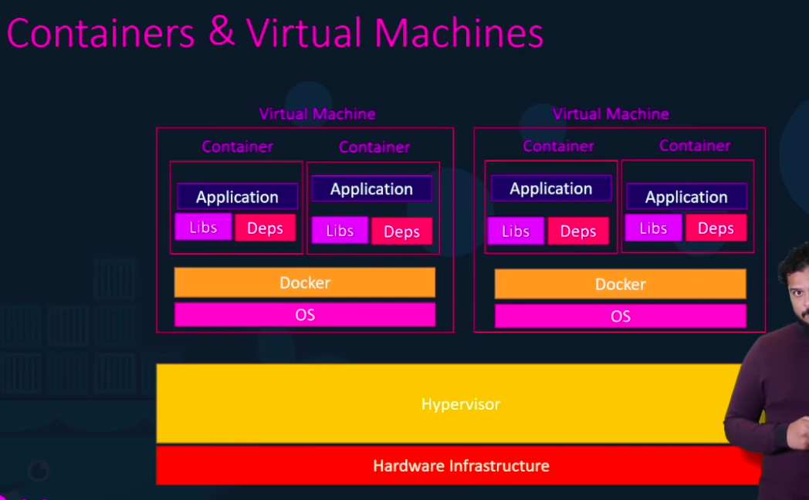

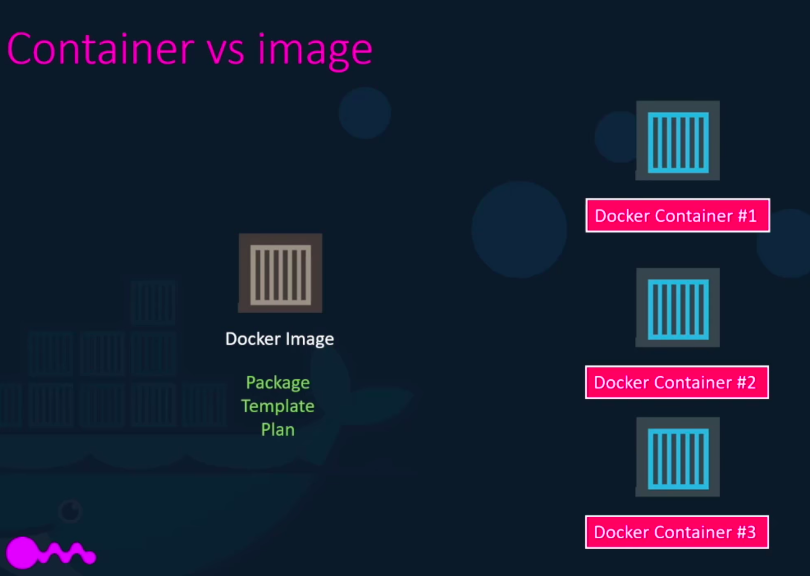

Commands

sudo docker version – Lists the details about the client and the server communities.

docker run nginx – It looks for an image of nginx first locally and then pulls it from docker hub. It forms a container and then exexutes the process required.

docker ps – Lists all the running docker containers and some basic information about them.

docker ps -a – Lists all the containers, running as well as exited.

docker stop {name}/{container Id} – Stops the container execution. Prints the name/Id upon stopping.

docker rm {name} – Remove the container.

docker images – Lists all the images in local communnity

docker rmi {name} – Removes the image.

docker pull {image name} – Pulls the image and not run.

Containers are meant to mean specific processes only. Post completion of tasks, it exits. As long as process is alive, container is up.

docker run ubuntu sleep 5 – Appends the sleep command to the container. Waits until sleep command exits.

docker exec {name} {command} – It helps us execute the command while the docker container is running. We don’t need to chain the command.
Attach and Detach modes
Normally docker commands are executed in the attach mode wherein the console isn’t available until the process is dead(say, a server is up).

To get through we can use detach mode (-d) while executing the commands. This performs the operation in the background.

docker run -d kodecloud/simple-app

While executing the app in background, if you want to attach get the ID that is returned after executing the background command say a04e30...

docker attach a04e30 //first few characters are enough

docker run redis:4.0 – The blue tag is basically the version that we need or the one which we want to pull from the docker hub.

Now upon dockerising a shell application simply won’t get the input. Also, it won’t show a prompt.
To get the prompts and input, we need to provide the -i and -t together as -it. -i works for interactiveness and -t gives us sudo terminal.

Thus, executing the shell script as: docker run -it prompt.sh will get us the required result.

PORT Mapping

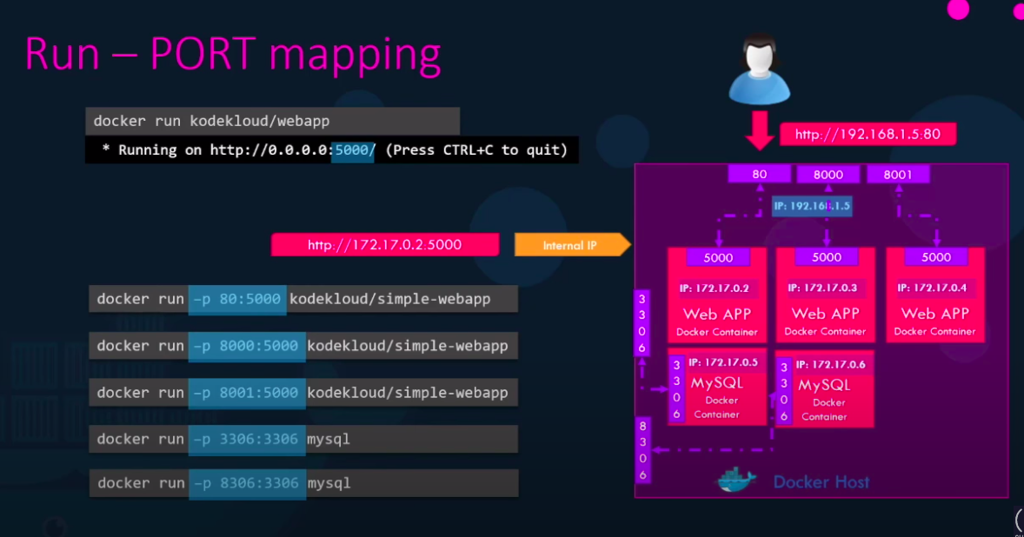
Imagine we’re working on several instances of mysql(database) and using many servers. Upon dockerisation, they are alloted specific IP addresses. These IP address of the containers need to be mapped to a port in the Docker Host.

It can be done simply by the command:
docker run -p 80:5000 webapp
Here, 80 is the portof the docker host and 5000 is the port of the container we are re-routing our traffic to.

Docker-Volume Mapping
As soon as we delete our container, all our data in the container is lost. If we would like to hold onto our data, we should map say the databse to a external directory in the docker host.

docker run -v /opt/datadir:/var/lib/mysql mysql

* docker ps lists only the general details about a container. If you want to gain more insight, try docker inspect {name}
Container logs are available from: docker logs {name}

To rename a docker container while creating:

docker run -d --name webapp nginx

